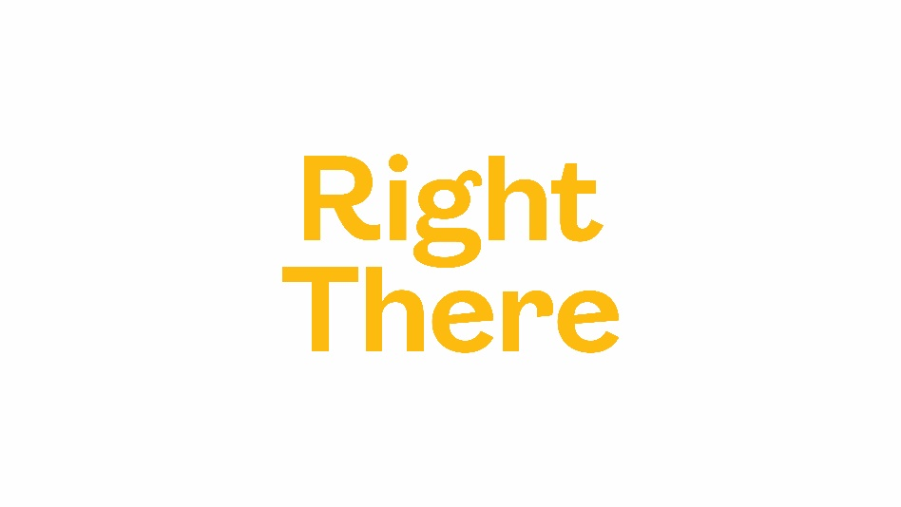

Right There Youth Counselling Service
Referral Form
Referrer name: | Job title and agency (if applicable):
Contact email: | Contact telephone: |  | Referral date:
Name of Young Person: | Name of parent(s)/carer(s) if under 16: |  | Gender:
School Attended: |  | DOB: | Age:
Home Address:  Postcode: | Young person telephone:  Parent/carer telephone: |  | GP:  Social worker (if applicable):
Is the young person: Subject to a supervision order ☐ Involved with Children’s Reporter ☐

Looked after and accommodated ☐ A young carer ☐
Is the young person is a personal user of the following:
Alcohol ☐ Drugs ☐
NPS/Legal Highs ☐ Solvents ☐

Has the young person been directly affected by:
Parental/carer alcohol misuse ☐ Parental/carer drug misuse ☐
Does the young person have any dependants?
Yes ☐ No ☐
Please give further details, where possible:

Is the young person experiencing any of the following mental or emotional wellbeing issues:
Stress ☐ Anxiety ☐
Depression ☐ Self-Harm ☐
Suicidal ideations ☐ Anger ☐
Low confidence ☐ Low self-esteem ☐

Other (please specify):
Please use this space to give more details about the referral where applicable:

Disability – do you consider the young person to have:
No disability or impairment ☐ A sensory impairment ☐
A learning disability ☐ A physical impairment ☐
A mental health condition ☐ Any other disability or impairment ☐

Brief description of disability:

Ethnic Group (background or culture) - is the young person:
White Scottish ☐ Other (South) Asian ☐
Other White British ☐ Chinese ☐
White Irish ☐ Caribbean ☐
Other White ☐ African ☐
Indian ☐ Black Scottish and other Black ☐
Pakistani ☐ Mixed ☐
Bangladeshi ☐ Other ☐
Consent

Please ensure that the young person is fully aware of the content of this referral before signing the form below.

Referrer: _______________________________ Date: ______________

If you have any queries about the y-talk service or wish to discuss this referral, then please contact us on 07770 019147 or email y-talk@rightthere.org
referrals can be sent by email to: y-talk@rightthere.org or posted to:
y-talk, Right There, Orkney, Glaitness Farmhouse, Kirkwall, KW15 1TN

