Biology of Fertility
The Biology of controlling fertility
- Fertile Periods
Objectives from this section are as follows –
- Infertility treatments and contraception are based on the biology of fertility.
- Cyclical fertility in females leading to a fertile period.
- Continuous fertility in males.
- Calculation of fertile periods and their uses.

Pupil notes
In human males, there is a relatively constant level of FSH and ICSH in the bloodstream
Therefore, a steady quantity of testosterone is secreted and a steady quantity of sperm produced
As a result, human males are continuously fertile
Cyclical fertility is in marked contrast with the continuous fertility in males
The interplay of pituitary and ovarian hormones results in the period of fertility being restricted to the 1-2 days following ovulation
The indicators ‘Temperature’ and ‘Mucus’ can be used by a woman to calculate her fertile period
This is obviously of use to a couple who are wishing to conceive
Approximately 1 day after the LH surge which triggers ovulation, a woman’s body temperature rises by 0.2-0.5 C
It remains at this elevated level for remainder of the luteal phase
Fertile period lasts for about 1-2 days
The infertile period is resumed after the 3rd daily recording of higher temperature
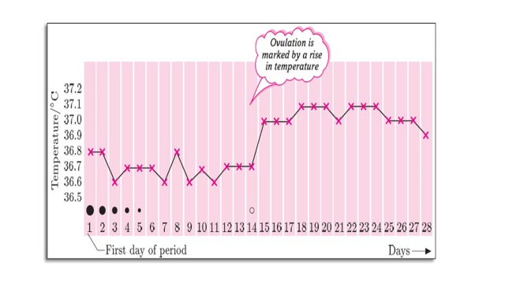
The cervical mucus secreted into the vagina during the fertile period is thin and watery
This allows easy access of sperm to the female reproductive system
After ovulation, progesterone causes the mucus to gradually increase in viscosity

