Treatments for Infertility
The Biology of controlling fertility
(ii) Stimulating ovulation, Artificial insemination and ICSI
Objectives from this section are as follows –
- Ovulation can be stimulated by drugs that prevent the negative feedback effect of oestrogen on FSH secretion.
- Other ovulatory drugs mimic the action of FSH and LH.
- These drugs can cause super ovulation that can result in multiple births or be used to collect ova for IVF programmes.
- Artificial insemination is particularly useful where the male has a low sperm count.
- Several samples of semen are collected over a period of time.
- If a partner is sterile a donor may be used.
- Intracytoplasmic Sperm Injection – if mature sperm are defective or very low in number ICSI can be used.
- In this technique the head of the sperm is drawn up into a needle and injected directly into the egg to achieve fertilisation.

Pupil notes
Infertility treatments and Contraception are based on the Biology of fertility
Sometimes there is a failure of the pituitary gland to secrete adequate FSH or LH
Ovulation can be stimulated by
- Drugs that mimic the normal action of FSH and LH
- Drugs that prevent the negative feedback effect of oestrogen on FSH secretion
These drugs can be so effective that they bring about ‘Super Ovulation’ which can lead to multiple births
Super ovulation can be used to collect ova for IVF
Artificial Insemination
This involves the insertion of semen into the female tract by some means other than sexual intercourse
It is particularly useful where a male has a low sperm count
Several samples of semen are collected and each is preserved (freezing) until required
They are then defrosted and released together into the partner’s cervical region during her fertile period
If a partner is sterile, artificial insemination can be used to insert the semen of a donor who has a normal sperm count into the female reproductive tract
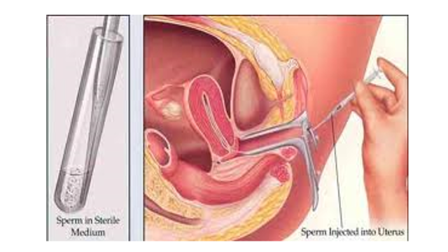
Intracytoplasmic Sperm Injection (ICSI)
This technique is employed when a man’s sperm count is low
Or, many of the mature sperm are defective
The procedure involves drawing a healthy sperm into a needle and injecting it directly into an egg – to achieve fertilisation
