In Vitro Fertilisation
Objectives from this section are as follows –
- Surgical removal of eggs from the ovaries after hormone stimulation.
- The eggs are mixed with sperm in a culture dish.
- The fertilised eggs are incubated until they have formed at least 8 cells and are then transferred to the uterus for implantation.
- Pre-implantation genetic screening can be used at this stage to identify genetic disorders and chromosome abnormalities.

Pupil notes
IVF enables fertilisation, outside the body, in a culture dish
IVF overcomes the problem of infertility caused by a blockage of the oviducts
It takes place in the following 6 stages –
1. woman is given hormone treatment to stimulate multiple ovulation
2. Surgical removal of the eggs from the ovary, using equipment like a syringe
3. eggs are mixed with sperm in a culture dish, containing nutrients, to allow fertilisation to take place
Alternatively, sperm may be injected directly into the egg using ICSI
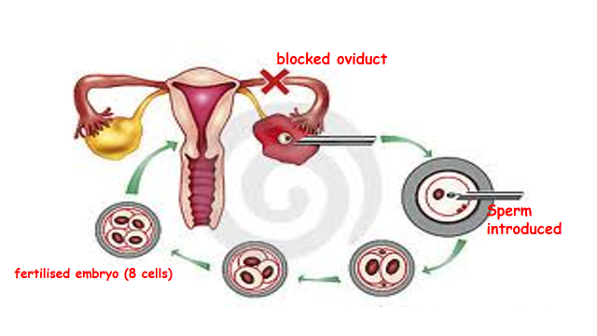
4. Fertilised eggs are incubated for 2-3 days to form embryos of at least 8 cells or more
Pre implantation screening can be employed at this stage to identify genetic disorders and chromosomal abnormalities
5. two (or three) embryos are inserted into the uterus for implantation
6. remaining embryos are frozen in case a second attempt is needed
Pre implantation Genetic Screening (PGS) and Pre implantation Genetic Diagnosis (PGD)
PGS is a non-specific approach
It checks the embryos for single gene disorders and common chromosomal abnormalities
PGD is a specific approach
It is used to check for a known gene of chromosomal defect
Ethics of PGS and PGD
People who support these practices –
believe they offer reassurance to couples at high risk of producing children with serious genetic disorders
It may also be claimed that the reduced frequency of genetic diseases is of benefit to society
Others believe it is morally wrong to make conception ‘selective’
They say that these procedures could be the start of Eugenics – human race could be subject to ‘selective breeding’ and this could lead to ‘designer babies’
Health issues
About 6% of patients undergoing treatments, involving drugs to stimulate the ovaries, suffer hyperstimulation of their ovaries
Medical experts are concerned about an increased risk of uterine cancer in later life
Most children conceived through IVF have a mass at birth which is significantly lower than normal
Children born with low birth weight are more likely to suffer long term health problems in later life –
these include obesity, diabetes, hypertension and heart conditions (same may be true for IVF children)

