(iii) Contraception
Objectives from this section are as follows –
- Biological basis of physical methods such as barrier methods, avoiding fertile periods, intra uterine devices and sterilisation procedures.
- Chemical contraceptives are based on combinations of synthetic hormones that mimic negative feedback preventing the release of FSH/LH, prevent implantation (‘morning after pills’) or cause thickening of the cervical mucus (‘mini pill’).

Pupil notes
The prevention of conception (or pregnancy) by natural or artificial means
Physical methods (3)
Barrier Method
The barrier method physically blocks the ability of the sperm to reach the ovum
Devises include
Condom (fits over penis)
Diaphragm (dome shaped rubber cap inserted into the vagina blocking the cervix)
Cervical cap (rubber structure which fits tightly around the cervix and can be left in place for a few days)
Avoidance of ’Fertile Period’ is also a method of contraception
Intra Uterine Device
An IUD is a plastic T-shaped structure with copper wound around its outside
It is fitted into the uterus for months (or even years)
It has threads attached for easy removal
It prevents the implantation of an embryo
It should really be termed a contragestic device as it prevents gestation
The presence of an IUD stimulates the presence of white blood cells which are hostile to sperm (and embryo)
It impairs the mobility of the sperm
It irritates the lining of the uterus, making it unreceptive to the embryo
IUD can cause complications – inflammation of the uterus and Ectopic Pregnancy
Many people are uneasy about the Ethics involved
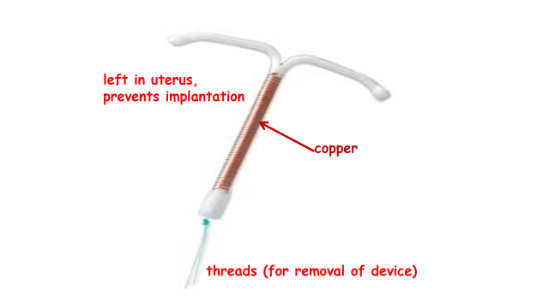
Sterilisation Procedures
3(a). Vasectomy
This involves cutting and tying the two sperm ducts
This prevents sperm being released
The sperm produced undergo Phagocytosis
3(b). Tubal Ligation
This involves cutting and tying the two oviducts
This prevents eggs meeting sperm
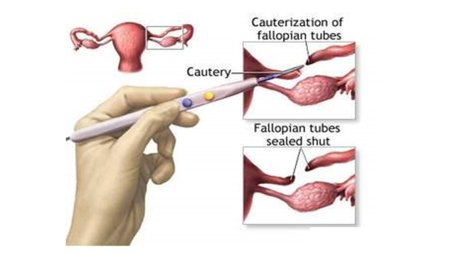
Chemical methods of Contraception
Pills containing a combination of hormones
Oral contraceptive pills usually contain synthetic oestrogen combined with synthetic progesterone
The pill is taken every day for 3 weeks from the final day of the previous menstrual period
This increases the concentration of oestrogen and progesterone in the bloodstream and exerts negative feedback control
Secretion of FSH and LH by the pituitary is inhibited
Follicle maturation remains inhibited
Ovulation does not occur
Placebo pills are taken during week 4 to allow oestrogen and progesterone levels to degrease
As a result, menstruation takes place
‘Morning-after Pill’
Contain higher doses of hormones than the standard oral contraceptive pill
They are taken after unprotected sex to prevent implantation (if fertilisation has occurred)
‘Mini Pills’
These are known as progesterone-only pills
They do not contain synthetic oestrogen
Mini pills thicken the cervical mucus, reducing the viability of sperm
This form of contraception can also be given as an implant, under the skin
It can give protection for up to 3 years
These are known as progesterone-only pills
They do not contain synthetic oestrogen
Mini pills thicken the cervical mucus, reducing the viability of sperm
This form of contraception can also be given as an implant, under the skin
It can give protection for up to 3 years
Advantages include -
Can be used during breast feeding
Can reduce cramps and heavy bleeding
Can be taken by women who cannot take oestrogen
Can be taken by women who have high blood pressure
Disadvantages include -
Must be taken at the same time every day
Can cause breast tenderness
Can cause mood swings
Can lead to weight gain
Can lead to irregular menstruation

