Medical Evidence

President Kennedy’s Jacket

Where exactly did the back wound shot penetrate? And, was it possible for the bullet to go through both Kennedy’s body, strike Governor Connally, break his ribs` and shatter his wrist – the so-called ‘Magic Bullet’?

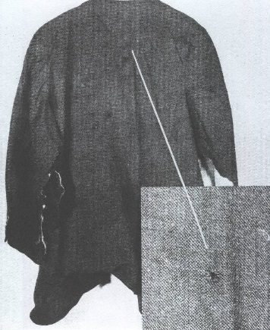

Direction of the shot

**When the Warren Commission Drawing [right above] is turned so that President Kennedy is in the same position shown in frame 312 of the Zapruder Film, the path of the bullet is rising not descending, as it would if fired from the sixth floor of the Book Depository Building**

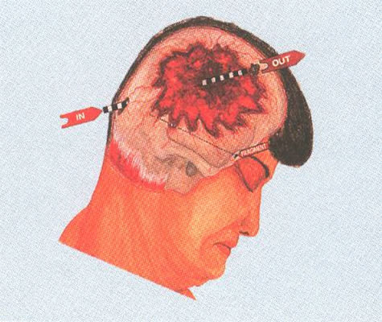

Autopsies

Was Kennedy’s body secretly removed at some point between leaving Parkland’s Hospital, Dallas, and its arrival at Bethesda Naval Hospital, Washington? If so, why?

Could there have been a point after the assassination when Kennedy’s body was secretly removed and sent elsewhere for a separate autopsy and, if so, why? There was a 14 minute period when Kennedy’s coffin was left unattended on board *Air Force One*

Were there two autopsies?

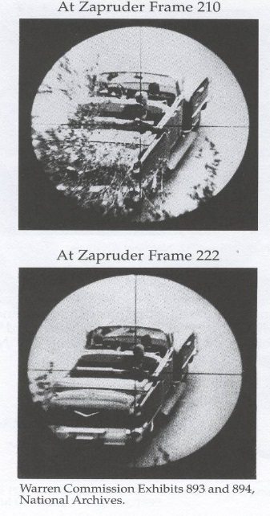CIA Renactments

The FBI failed to use the Presidential Limousine in their re-enactment. Yet the Warren Commission claimed the re-enactment supported the Single Bullet Theory, even though, when viewed through a telescopic sight from the sixth-floor window, the wounds of the President and the Governor did not line up.

Marksman

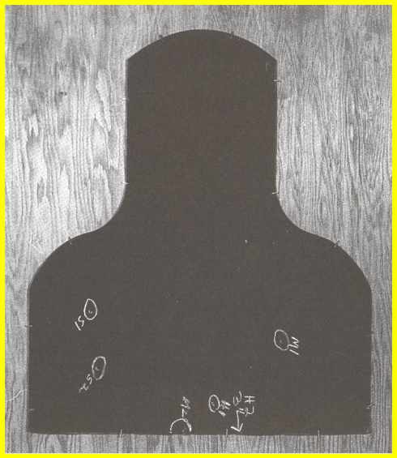One of the three Rifle Test targets

Although marksmen hit this target five times, none of the shots hit the head or neck region. JFK was killed by a headshot.

Oswald and Tippet

There is also controversy over the killing of police officer Tippets, who Oswald was accused of murdering. Some witnesses claim their was more than one gunman and that neither looked like Oswald.

Was Oswald being set up?

