Air Pressure Homework
Hypothesis: (what you think will happen)
Air pressure will predict what the weather is likely to do for the next 24 hrs

Method: (what you do to find out)
For this task you are going to gather your own data (when you gather the results for yourself it is called a primary data)
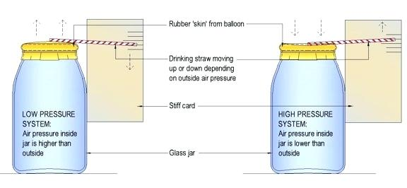
Build a barometer, either use the diagram to help you or try one of the different versions you can find online e.g. wiki how

At the same time each day look at the gauge and not if the arrow is pointing up (High pressure) or Down (low pressure)
When you check again the following day write in your sheet what the weather actually was for the previous 24 hrs e.g. Wet, windy, cold, warm
Analysis of results: (what you actually found out)
  - Which day had the best weather
  - Which day had the worst
  - Was there a pattern between where the needle pointed and what weather you experienced for the next 24 hrs?

Conclusion: (did you prove your hypothesis? –it’s ok if you didn’t!)
Air pressure Did/Didn’t seem to predict the weather
Data collection sheet
Day | Arrow pointed up or down | What the Weather actually was like  e.g. Good/ fair/bad⁺ it is your choice how detailed you want to be here
Monday
Tuesday | Straight | 35 mph winds 12⁰C 44 mm of rain
Wednesday | Up
Thursday
Friday
Saturday
Sunday
After you have collected your data for 7 days answer the following questions
Analysis of results:
- ______________ had the best weather
- ______________ had the worst weather
- Was there a pattern between where the needle pointed and what weather you experienced for the next 24 hrs?

Conclusion : Air pressure Did/Didn’t* seem to predict the weather
^{(*Score out as appropriate)}

