**Kirkwall Grammar School**



Biology

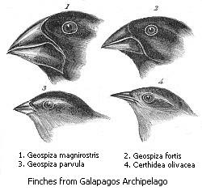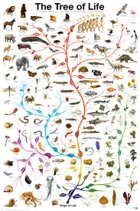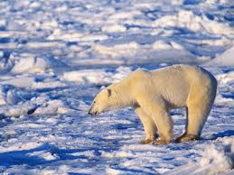

**Adaptations, Natural Selection & Evolution**

Pupil Booklet

Name __________________

Class ____________________

Teacher ____________________

(KGS N4N5)

1. Mutations

1. What is a mutation?

2. What is a mutant?

3. What is Variation?

4. a) What are mutagenic agents?

b) What are the 2 main categories of mutagenic agents?

c) Write down an example of a mutagenic agent from each category.

-

-

5. What are the 3 different impacts of mutations on an organism?

1)

2)

3)

2. Adaptations

6. Define the term adaptation

7. Why do organisms need to adapt?

8. What are the 3 types of adaptations?

-

-

-

9. Research specific examples of animals and plants that show interesting adaptations and present your findings as a scientific poster. Include some of the following examples:

* + Desert mammals
  + Orchids
  + Bee pollinated plants
  + Galapagos Finches
  + Desert plants
  + Freshwater/saltwater fish
  + Any other interesting examples you wish to include

Notes:

3. Natural Selection

10. First of all, find out information about the following:

Charles Darwin:

11. Give some examples of variation in humans:

-

-

-

-

12. Give some examples of variation in other organisms:

-

-

-

-

13. What does it mean when an organism ‘struggles for survival’?

14. What does the term ‘survival of the fittest’ mean?

15. What is a selective advantage?

16. Complete the following diagram by filling in the boxes.

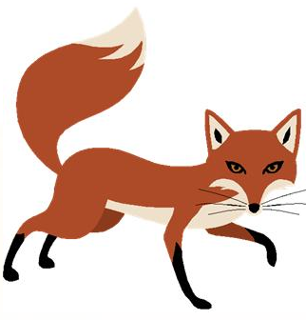

17. Write a short account about the natural selection of the peppered moth BEFORE the industrial revolution when air was clean

-

-

-

-

-

18. Write a short account about the natural selection of the peppered moth DURING/AFTER the industrial revolution when air/buildings were darkened with soot

-

-

-

-

-

4. Speciation

|  |  |
| --- | --- |
| Term | Definition |
| Species |  |
| Population |  |
| Gene pool |  |
| Speciation |  |

19. Complete the following table:

20. List 3 different isolating mechanisms:

-

-

-

21. Now give 2 examples of each:

|  |  |  |
| --- | --- | --- |
| Isolating Mechanism | Example 1 | Example 2 |
|  |  |  |
|  |  |  |
|  |  |  |

22. Use diagrams to explain the process of speciation.

23. Use the following plan to help write a 5 mark piece on Speciation, using real examples to complete your answer (you may bullet point your answer if you wish).

1. Name one type of isolation that could prevent gene exchange between 2 sub-populations. 1
2. Over a long period of time, the gene pools of 2 sub-populations become different from one another. Explain separately how **mutations** and **natural selection** account for these differences. 3
3. What evidence would confirm that speciation had occurred. 1

----------------------------------------------------------------------------------------------------------------------------------------------------------------------------------------------------------------------------------------------------------------------------------------------------------------------------------------------------------------------------------------------------------------------------------------------------------------------------------------------------------------------------------------------------------------------------------------------------------------------------------------------------------------------------------------------------------------------------------------------------------------------------------------------------------------------------------------------------------------------------------------------------------------------------------------------------------------------------------------------------------------------------------------------------------------------------------------------------------------------------------------------------------------------------------------------------------------------------------------------------------------------------------------------------------------------------------------------------------------------------------------------------------------------------------------------------------------------------

----------------------------------------------------------------------------------------------------------------------------------------------------------------------------------------------------------------------------------------------------------------------------------------------------------------------------------------------------------------------------------------------------------------------------------------------------------------------------------------------------------------------------------------------------------------------------------------------------------------------------------------------------------------------------------------------------------------------------------------------------------------------------------------------------------------------------------------------------------------------------------------------------------------------------------------------------------------------------------------------------------------------------------------------------------------------------------------------------------------------------------------------------------------------------------------------------------------------------------------------------------------------------------------------------------------------------------------------------------------------------------------------------------------------------------------------------------------------------