Hypothesis - What you think will happen?
Earthquakes that happen in the poor countries do more damage than those that occur in rich countries
Methods – What did you use to find your information?
I chose to use websites/books to find information. This is a reliable method because the website/book was up to date/had a lot of information.
Background Reading – Your research
The two earthquakes that I am using to study my hypothesis are the Haiti earthquake in 2010 and the San Francisco 1989 earthquake.
For Example:
Haiti is a small country ______ and is ___ km² with a population of ________
The earthquake measured _ on the Richter scale and killed __ people
The earthquake was caused by _______ and _________ plate boundaries
Before the quake the government of Haiti took ____ action
After the quake ___________ tried to help by ________
Processed Information – Present your findings
For example:
 | Haiti | San Francisco
Size of earthquake
Cost of damage
Deaths
If you find any other maps or graphs you might like to put them in here as well.
Analysis - What did you find and why did things happen?
My information shows that ________ Earthquake was larger but killed more people. This was because ______ the ________ Earthquake was smaller but cost more to fix the damage, this might be because______________________________________________________________________.
Conclusion – Summarise your results
In conclusion, while the Haiti earthquake caused more deaths it cost less to replace the damage. So I cant fully say that Earthquakes that happen in the ELDC’s (poor countries) do more damage than those that occur in EMDC’s (rich countries)
Bibliography State where you found your information
BBC Bitesize. Available at: www.bbcbitesize/Geography/Earthquakes.com Accessed 23/11/17
Haiti Help Sheet
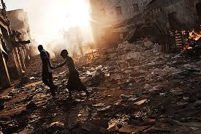
• Poorest country in the Western Hemisphere
• Total population of Haiti is 10 million
• ELDC with a rapidly growing population
• Haiti is near to the boundary between the North American and Caribbean Plate
• The earthquake hit on the 12th of January 2010
• It was a magnitude 7 earthquake
• There has not been a big earthquake on that fault since 1750.
• The initial quake was quickly followed by two strong aftershocks of 5.9 and 5.5 magnitude.
• A 5.9 aftershock hit on the 20th of January while people were still being rescued
• Over 200,000 people died
• 250,000 homes and 30,000 businesses were damaged
BBC Bitesize www.bbc.co.uk/bitesize/ks3/geography/physical_processes/plate_tectonics/revision/7/ Accessed 26/11/17

San Francisco Help Sheet
• San Francisco is found in the state of California in the United States of America
• Found close to the San Andreas Fault which is a plate boundary between the Pacific Plate and the North American plate
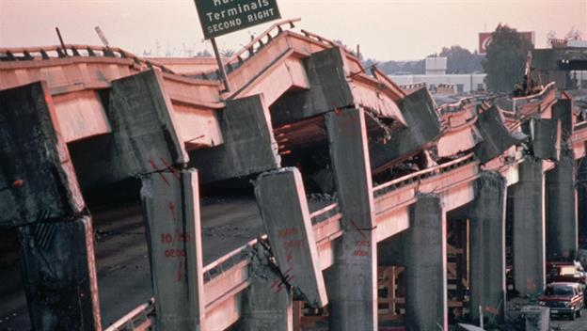
• It was a magnitude 6.9 earthquake
• The earthquake hit on the 17th of October 1989
• 63 people died and 3,757 people were injured
• 12,000 homes and 2,600 businesses were damaged

Encyclopaedia Britannica https://www.britannica.com/event/San-Francisco-Oakland-earthquake-of-1989 Accessed 26/11/17

