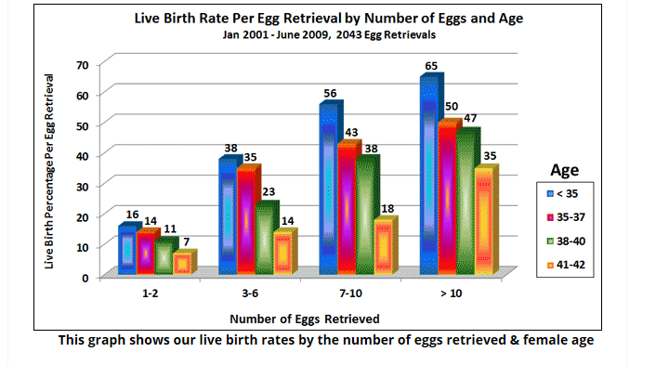
Reference
http://www.advancedfertility.com/eggspregnancyrates.htm

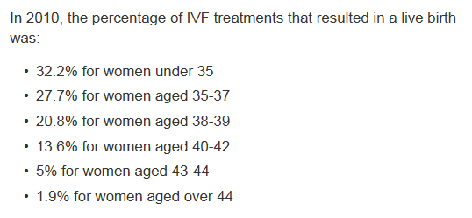

Reference
http://www.nhs.uk/conditions/ivf/pages/introduction.aspx

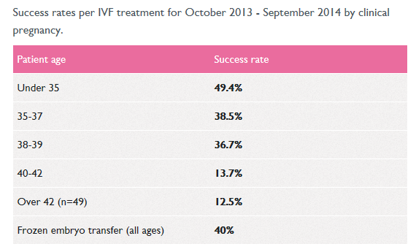
Reference
http://www.londonwomensclinic.com/london/success_rates

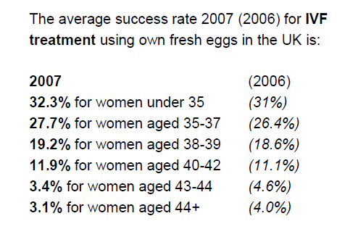
Reference
http://www.hfea.gov.uk/docs/2010-11-24_Facts_and_Figures_2007_Publication_Updated_November_2010_FINAL_pdf.PDF

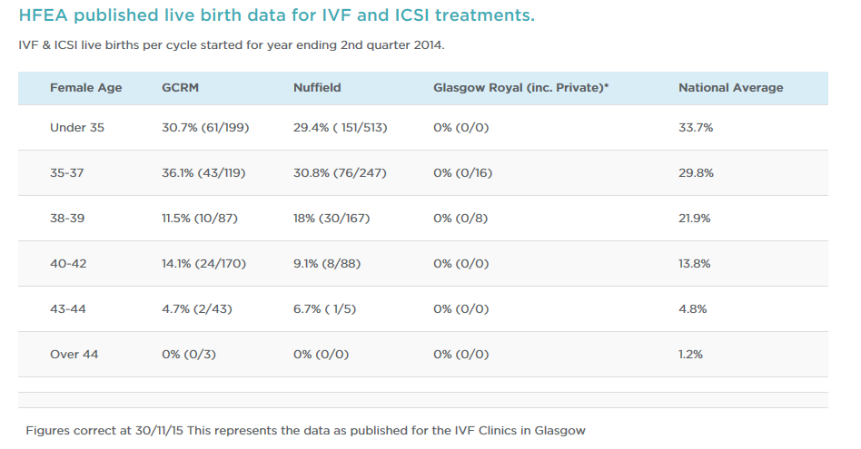

Reference
http://www.gcrm.co.uk/our-success/success-rates/

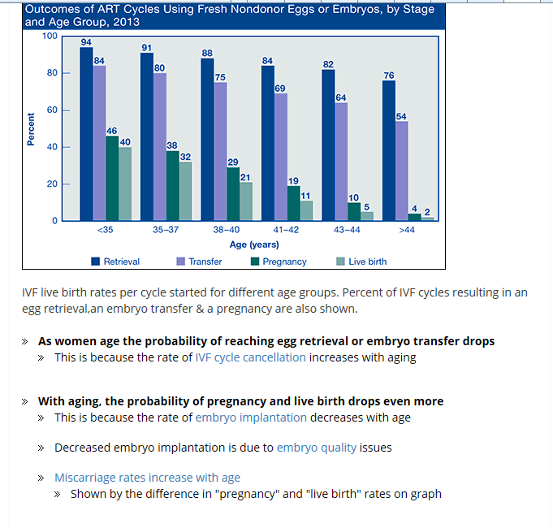
Reference
http://www.advancedfertility.com/ivf-age.htm

