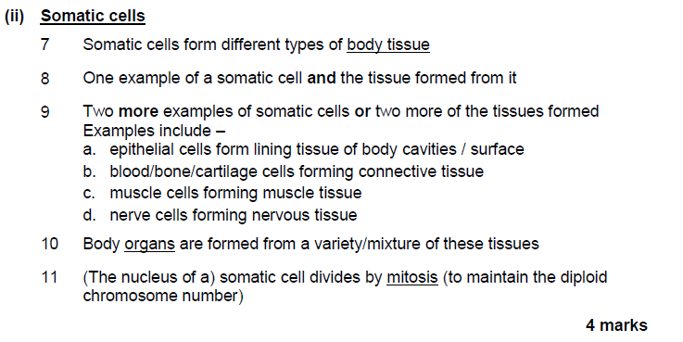
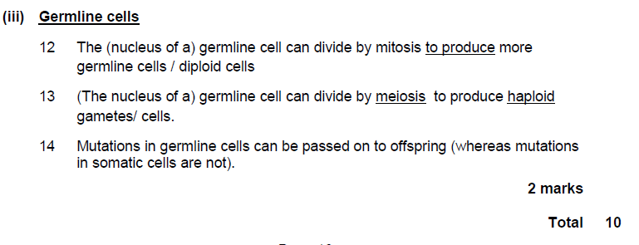
Marking Scheme for Higher Human biology
Stem Cells and Differentiation

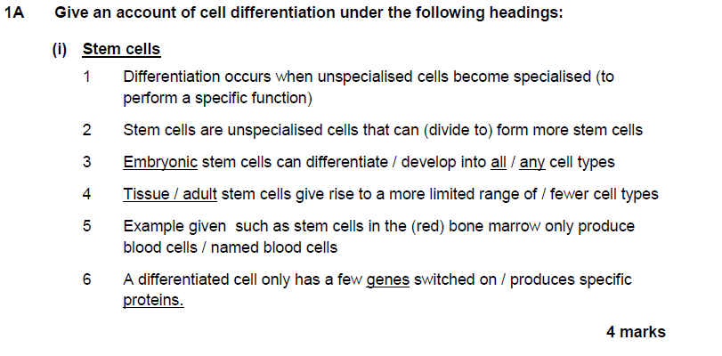
PP RHHB 2013

Q2 RHH 2012 Q1

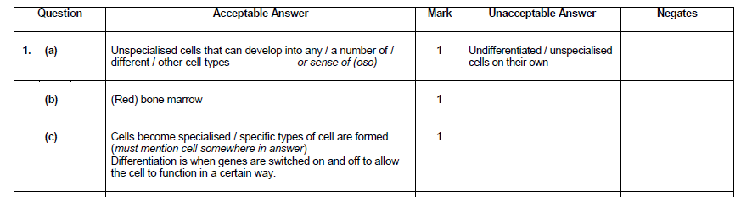
Q3 RHH 2014 Q1
